1. As we know OpenAPI Specification Doc can be used by some Auto-generation Tool which can generate initial code for both APIs Consumers and Producers.
2. So, using these Automated Code Generation Tools, we can generate the client code and server stubs.
3. 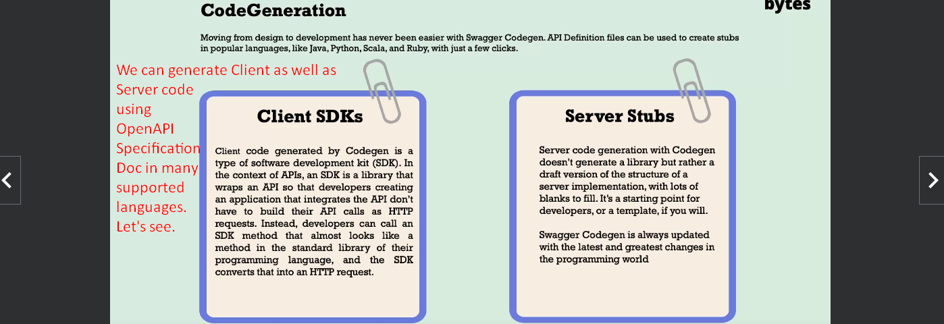
4. Mentor will download server code in NodeJS and Spring but I will document only Spring skipping NodeJS.
5. 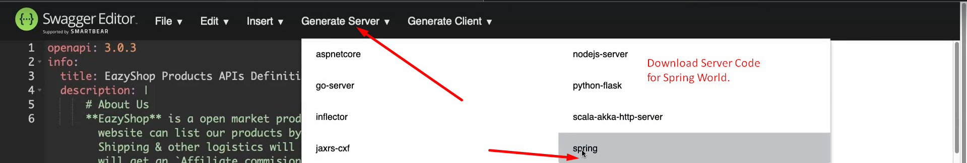  
     
   
6. 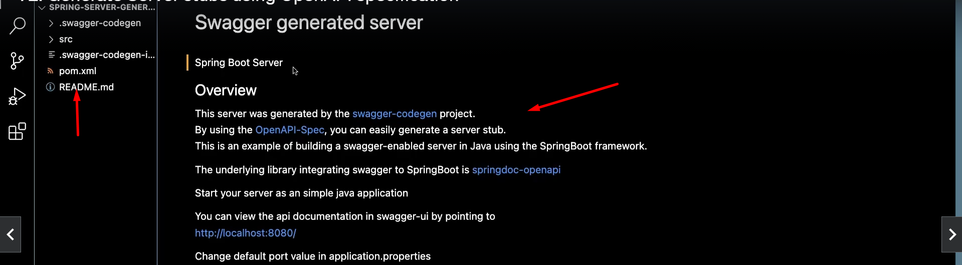
7. 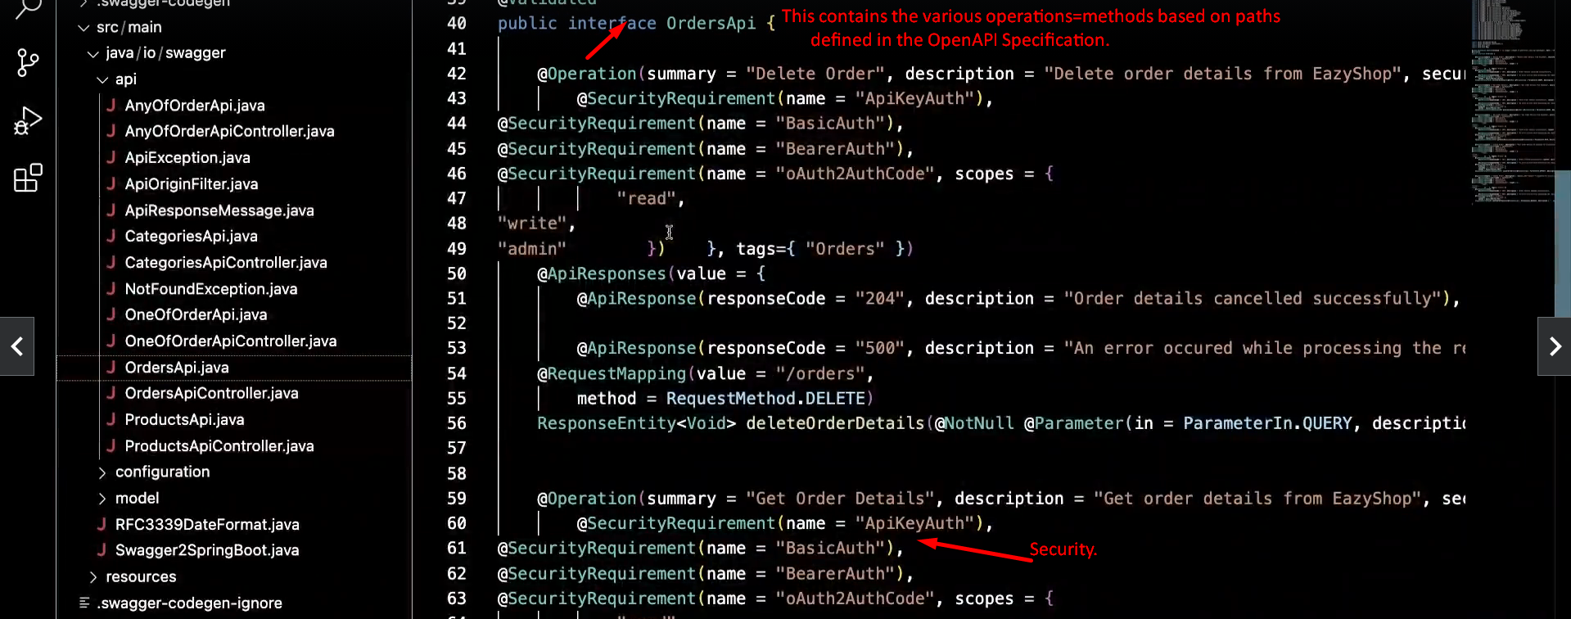
8. 